Sentinel - Incident Management System
A desktop application for logging, tracking, and resolving cybersecurity and IT incidents, built in Python with a role-based workflow and full audit trail.

Summary:
During my work experience at Envases, my supervisor gave me the task of creating an incident management system for tracking cybersecurity and IT incidents.
Sentinel is designed for tracking cybersecurity and IT incidents from initial report through resolution. It supports a role-based access for users and investigators. Users can create incidents to be logged, upload evidence, assign investigators, and view their incident status through a workflow. Investigators can view all these incidents, generate incident reports, reassign cases, and manage active incidents through a drag and drop Kanban style interface. Additionally, all user passwords are stored using secure hashing rather than plaintext.

Features:
- Role-based access: separate User and Investigator accounts, with an investigator verification code at registration
- Incident creation: log incidents with title, category, severity, description, and location
- Evidence upload: attach screenshots, images, PDFs, or text files to an incident
- Investigator assignment & reassignment: assign a case to an investigator, and reassign it later if needed
- Kanban style workflow board: drag incidents through New → Investigated → Contained → Resolved → Closed, with sequential status enforcement and a reopen exception for closed cases
- Full audit trail: every status change is logged with a timestamp and the user who made it
- Undo: reverse the last status change on the board
- Report generation: investigators can generate summary reports for resolved/closed incidents, with optional notes and recommendations
- Search & filter: filter incidents by status, category, severity, and date range
- Secure password storage: passwords are hashed (SHA-256), never stored in plaintext

Tech Stack
- Python
- CustomTkinter — GUI framework
- SQLite — local database
- Pillow (PIL) — image handling for evidence thumbnails

Dependencies
These are the external Python packages the project needs installed before it will run. Install them with pip:
pip install customtkinter
pip install pillow
customtkinter — the GUI framework used to build every window, button, and frame in the app.
pillow (PIL) — used to open and display image files, including the app logo and evidence thumbnails.
sqlite3 and tkinter are part of Python's standard library, so they do not need to be installed separately.

Setup Instructions
- Clone or download the repository
- Install dependencies: pip install customtkinter pillow
- Create the database (run once): python database.py
- Run the application: python smain.py
- Register an account — choose User or Investigator
- investigator role requires a verification code set in the code as INVESTIGATOR_CODE which is EnvasesWork{78}

GUI overview:
Login screen: Create Account screen: (code only shows on investigator)
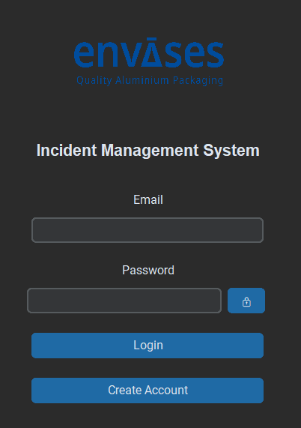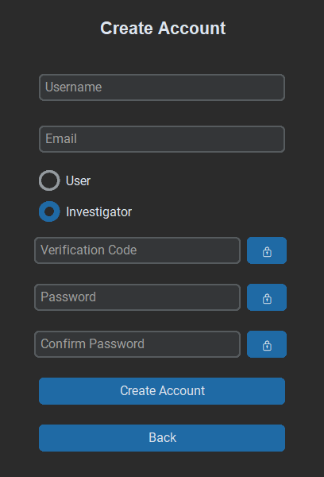

Investigator screen: Generate report screen:

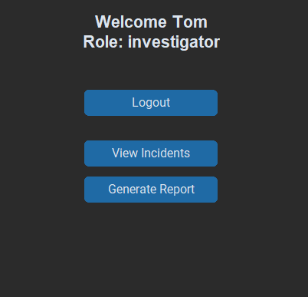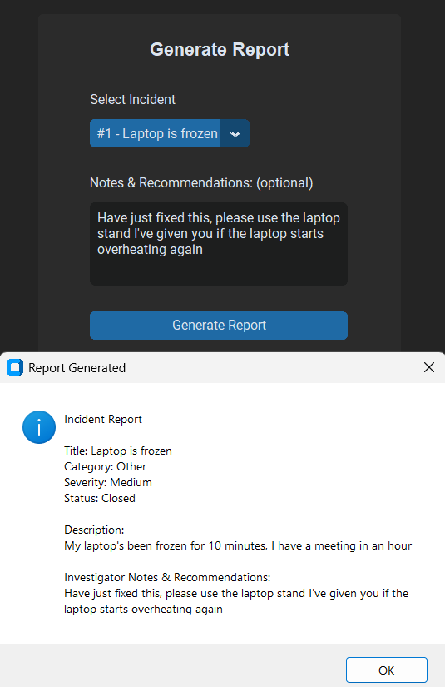

View Incidents screen: (both users & investigators can view, however, investigators only have access to edit incidents)

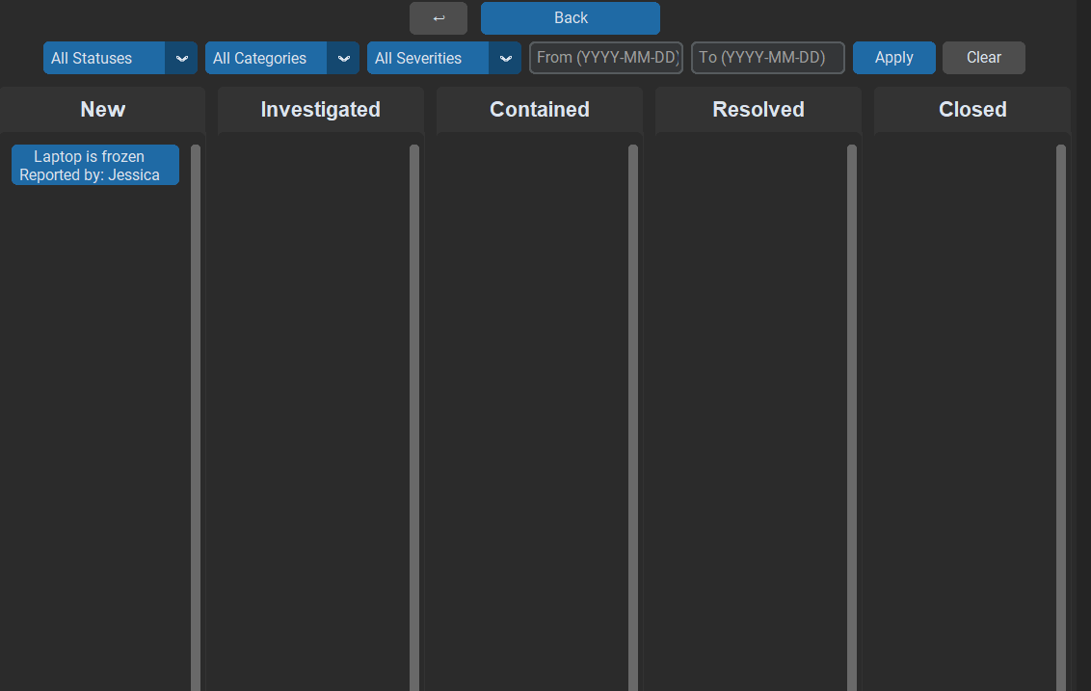

User screen: Upload evidence:

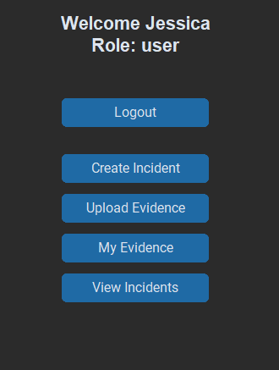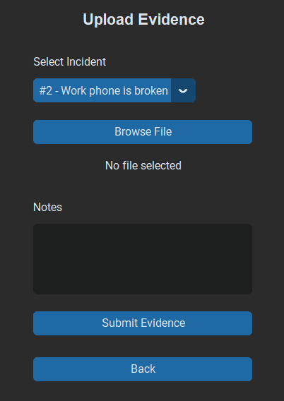

Create incident screen: Upload evidence screen:

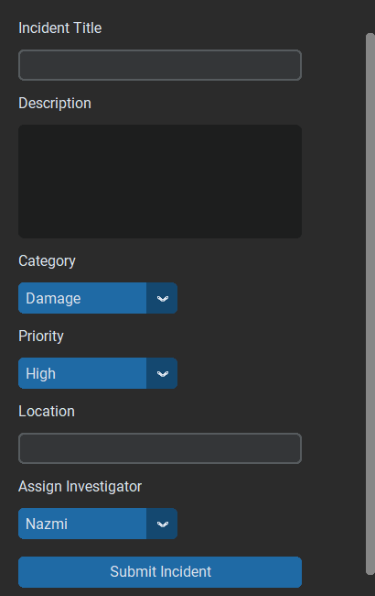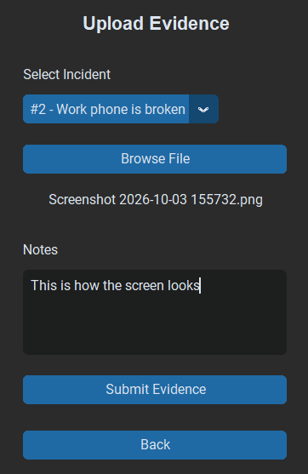

Future Improvements:
- Password reset flow
- Investigator availability toggle
- Visual redesign with a custom icon set

